Traceroute Project Report

Stanley Tian

EECS 325 Networks

Graphs:

RTT vs. Hops:

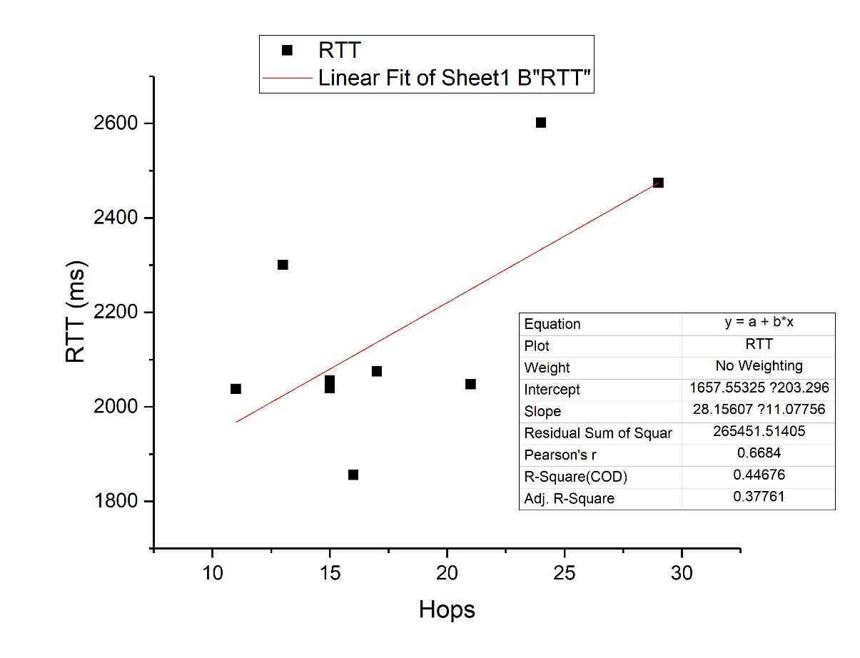

Geo distance vs Hops:

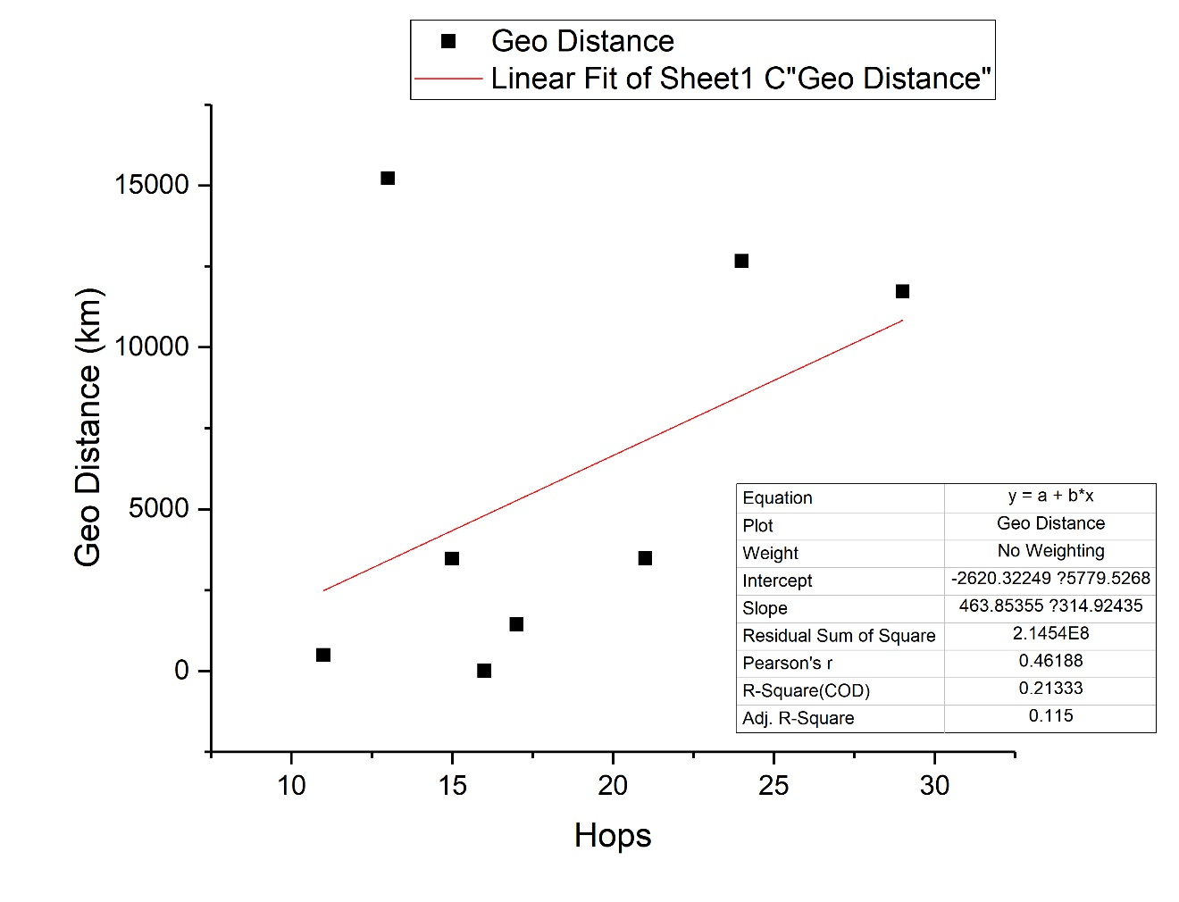

Geo distance vs. RTT: 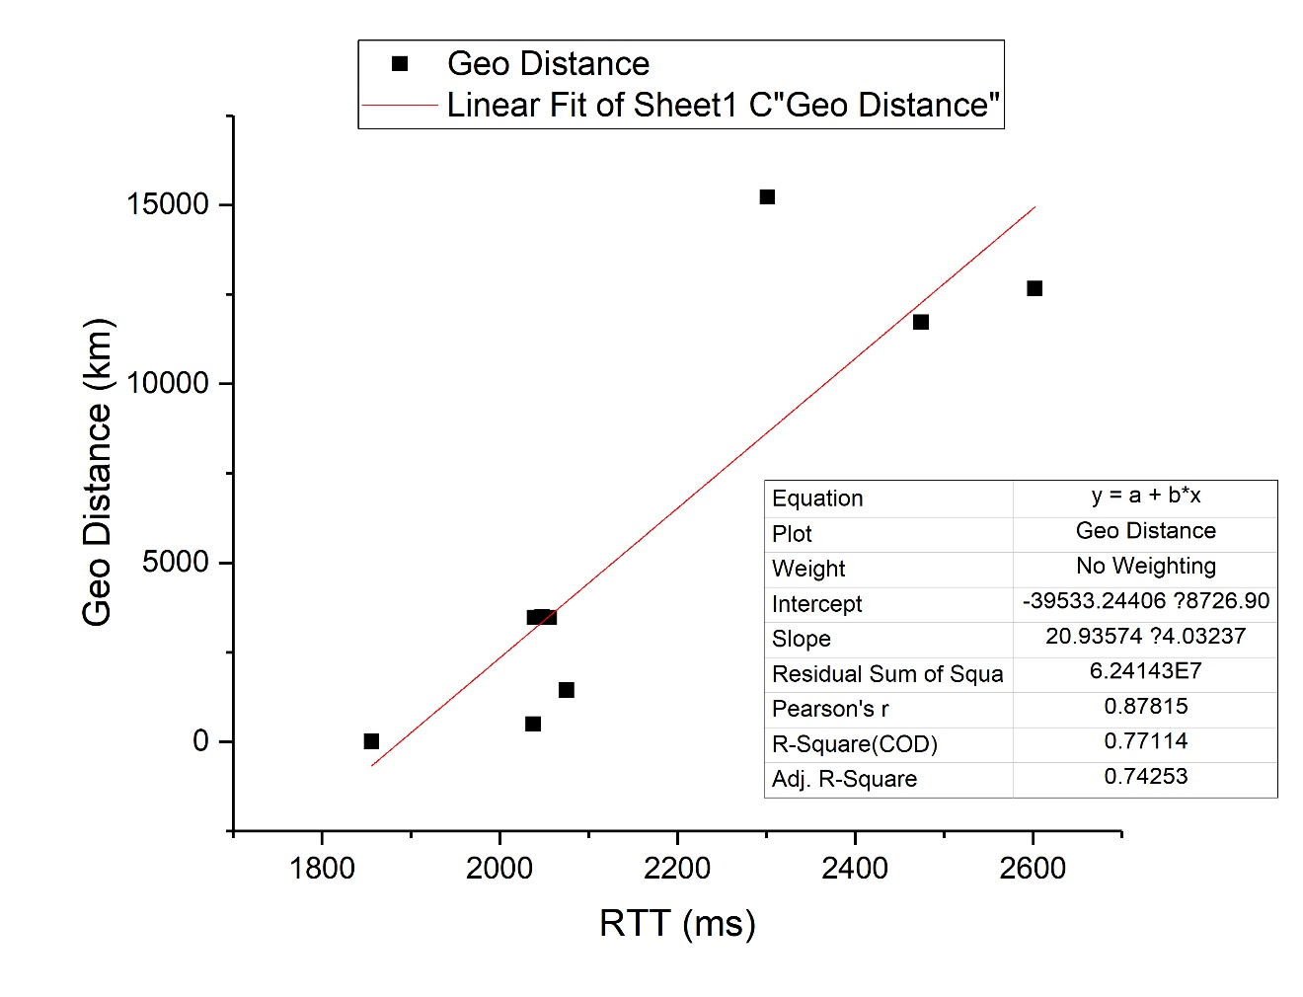

Q&A:

Q: how you will match ICMP responses with the probes you are sending out (list all ways you could think of in your report and use the one that you found to work for you).

**A: I will examine the specific ICMP message received to see if it contains some or perhaps all of the original data sent. If the ICMP does contain a substring of that original data, then it is definitely a response to my probes**

Q: list all possible reasons you can think of for not getting the answer when probing an arbitrary host

**A: 1. The host does not send ICMP message yet we only have one socket assigned to only receive this type of message**

**2. The server take this as an attack traffic and blocked it**

**3. Implementation of the host regarding ICMP is not up to standard**

**4. Packet lost**

**5. There’s a congestion and the timeout event was triggered**